LED Control Using Push Button Project
1. Introduction
This project presents a simple LED control system using a push button interfaced with an Arduino Uno microcontroller. The system enables the user to toggle an LED on and off with the press of a button. The project demonstrates basic principles of input and output operations, including how to interface a push button with a microcontroller and control an output device (LED). It also introduces concepts of state changes and debouncing in embedded systems.
2. Objectives
- To control an LED using a push button.
- To interface a push button with Arduino Uno.
- To toggle the LED state (ON/OFF) upon pressing the button.
- To implement a debouncing technique to ensure reliable button presses.
3. Components Used
Component | Description
Arduino Uno | Microcontroller used for processing and controlling the circuit.
Push Button | Input device used to change the LED state.
LED (Blue) | Output device to be toggled ON/OFF.
Resistor(330Ω) | Current-limiting resistor to protect the LED.
Resistor (1kΩ) | Pull-down resistor to stabilize the push button input.
Jumper Wires | Used for making necessary connections on the breadboard.
Breadboard | A platform to make connections without soldering.
4. System Description
The system consists of an input unit (push button), a processing unit (Arduino Uno), and an output unit (LED). The push button is used to toggle the state of the LED connected to the Arduino. The Arduino reads the state of the button and toggles the LED's state accordingly. A debounce mechanism is implemented in the software to prevent multiple LED state changes due to the physical bouncing of the button contacts.
5. Circuit Connections
Push Button Pin | Arduino Pin
One side of the button | Pin 3 (Digital Input)
Other side of the button | GND

LED Pin | Arduino Pin
Anode (Long leg) | Pin 7 (Digital Output)
Cathode (Short leg) | GND

6. Working Principle
The push button continuously monitors user input. When the button is pressed (changing its state from LOW to HIGH), the Arduino toggles the state of the LED. A debounce delay is included to ensure that only one button press is registered at a time. The LED is turned ON when it was previously OFF, and vice versa. The system responds to user input in real time, making it an effective demonstration of input/output handling in embedded systems.
7. Software Requirements
Arduino IDE: The software development environment used to write and upload code to the Arduino board.
8. Circuit Simulation
- Open Proteus software.
- Place Arduino Uno and LED on the workspace.
- Add a push button and connect it to pin 3.
- Connect the LED to pin 7.
- Add a virtual terminal to view output (optional).
- Load the Arduino code (HEX file) into the Arduino module.
- Run the simulation.
- Observe the LED toggling behavior on the virtual terminal.
9. Arduino Source Code
const int BUTTON_PIN = 3; // Button connected to pin 3
const int LED_PIN = 7; // LED connected to pin 7
int lastButtonState = LOW; // Last state of the button
int currentButtonState = LOW; // Current state of the button
void setup() {
pinMode(BUTTON_PIN, INPUT); // Set button pin as input
pinMode(LED_PIN, OUTPUT); // Set LED pin as output
}
void loop() {
lastButtonState = currentButtonState; // Save the last button state
currentButtonState = digitalRead(BUTTON_PIN); // Read the current button state
if (currentButtonState == HIGH && lastButtonState == LOW) {
digitalWrite(LED_PIN, !digitalRead(LED_PIN)); // Toggle LED state
delay(200); // Debounce delay
}
}
10. Expected Output
The system toggles the LED ON/OFF each time the button is pressed. The button state is read and processed, and the LED state is changed accordingly. A debounce delay ensures that only one press is registered per button click, preventing any accidental multiple toggles.
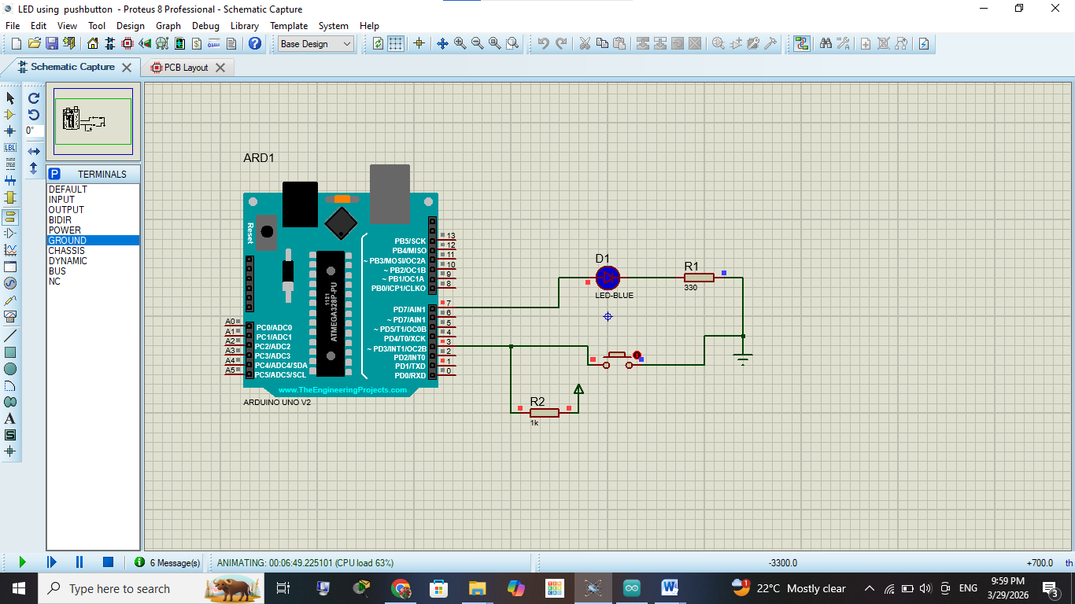
11. Applications
- Basic Input/Output Systems: A simple demonstration of controlling outputs based on input.
- Home Automation: Could be extended to control other devices such as lights or fans.
- User Interface for Projects: Provides a way to implement user-controlled interfaces in embedded projects.
- Embedded System Prototyping: Demonstrates how to interface buttons and LEDs in microcontroller-based systems.
12. Advantages
- Low-Cost Implementation: This project uses basic components which are inexpensive and readily available.
- Simple Design: The design of the circuit and software is straightforward, making it an ideal starting point for beginners in embedded systems.
- Real-Time Control: The system responds to user input instantly, making it an effective demonstration of input-output control.
- Low Power Consumption: The system only consumes power when the button is pressed, and the LED operates efficiently.
13. Limitations
- Limited Complexity: The system is quite simple and does not scale well for more complex input-output systems.
- No Data Storage: The system does not store or log any data for future use or analysis.
- No Feedback for Multiple Button Presses: The design does not provide feedback for multiple button presses other than toggling the LED.
14. Future Enhancements
- Use of Interrupts: Implement interrupts for more efficient button press handling, allowing for real-time responses without polling.
- Multiple LEDs: Extend the system to handle multiple LEDs, each controlled by different buttons.
- LCD Display: Integrate an LCD to display the current state of the LED (ON/OFF).
- Wireless Control: Implement wireless control of the LED via Bluetooth or Wi-Fi.
15. Conclusion
The LED control using a push button successfully demonstrates the basic principles of embedded system design, including input handling, output control, and software logic for state management. This simple project can be expanded with more complex systems and features, providing a foundation for building more advanced Arduino-based applications.

